Your hospital is participating in the National Emergency Laparotomy Audit.

Patient data collection has begun.

Don’t forget to enter the data!

For information and updates:

www.nela.org.uk
Follow @NELANews

NIAA

National Institute of Academic Anaesthesia
H S R C
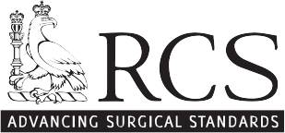
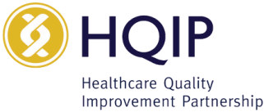
Health Services Research Centre

